CIS 2109 HW 5

10/19/2018

Scott O’Hara

4-54)

1. Identify the functional dependencies between the attributes.

AID -> ALname, AFname, AInst

BNbr -> BName, BPublish, PubCity, BPrice

AID, BNbr -> AuthBRoyalty

1. Identify the normal form in which the relation currently is.

The relation is not in any normal form because it has multiple value attributes.

1. Identify the errors in the data that have been made possible by its poor structural characteristics.

* Grey Brothers instead of Gray Brothers in the first row of AID: 32
* Boston, NH instead of Boston, MA in the first row of AID: 32
* Wall & Vintage has two different PubCity’s listed Chicago, IL and Indianapolis, IN not clear which is the correct city.

1. Take the actions (if any) necessary to convert the relation into the third normal form. Identify all intermediate steps.

1NF:

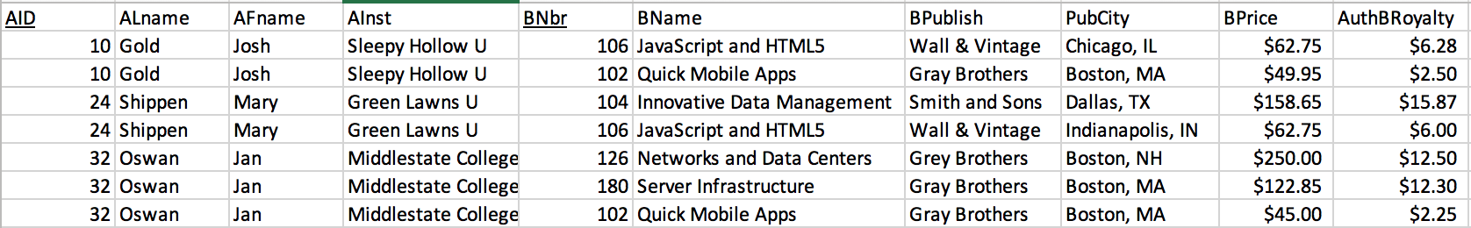

2NF:

AUTHORS (AID, ALname, AFname, AInst)

BOOKS (BNbr, BName, BPublish, PubCity, BPrice)

AUTHOR_ROYALTY_FOR_BOOK (AID, BNbr, AuthBRoyalty)

3NF:

AUTHORS (AID, ALname, AFname, AInst)

BOOKS (BNbr, BName, BPublish, BPrice)

BOOK_PUBLISHERS (BPublish, PubCity)

AUTHOR_ROYALTY_FOR_BOOK (AID, BNbr, AuthBRoyalty)

4-55)

1. Identify the functional dependencies between the attributes.

ComputerSerialNbr 🡪 VendorID, VendorName, VendorPhone, VendorSupportID, VendorSupportName, VendorSupportExtension, PurchasePrice

SoftwareID 🡪 SoftwareName, SoftwareVendor, SoftwareLicenseExpires, SoftwareLicensePrice

UserID 🡪 UserName, UserAuthorizationStarts, UserAuthorizationEnds, UserAuthorizationPassword

1. Identify the reasons why this relation is not in 3NF.

Transitive dependencies still present.

1. Present the attributes organized so that the resulting relations are in 3NF.

ComputerSerialNbr 🡪 PurchasePrice

VendorID 🡪 VendorName, VendorPhone, VendorSupportID, VendorSupportName, VendorSupportExtension,

SoftwareID 🡪 SoftwareName, SoftwareVendor, SoftwareLicenseExpires, SoftwareLicensePrice

UserID 🡪 UserName, UserAuthorizationStarts, UserAuthorizationEnds, UserAuthorizationPassword

4-58)

1. Identify the functional dependencies between the attributes.

RouteID 🡪 RouteStartPoint, RouteEndPoint, RouteStandardDrivingTime

ScheduleDate, ScheduleDepTime 🡪 ScheduledArrTime

DriverID 🡪 DriverFName, DriverLName, DateDriverJoinedCompany, DriverDOB

VehicleID 🡪 VehicleMake, VehicleModel, VehiclePassangerCapacity

DriverID, VehicleID 🡪 DriverCertStartDate, DriverCertEndDate

1. Identify the reasons why this set of data is not in 3NF and indicate the normal form (if any) it is in.

Full dependencies, and partial dependencies still exist. Also, multi valued attributes still exist, i.e. sample data.

1. Including all intermediate stages, organize the attributes into a set of 3NF relations.

1NF:

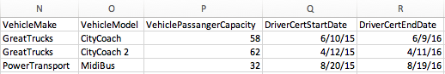

2NF:

ROUTE (RouteID, RouteStartPoint, RouteEndPoint, RouteStandardDrivingTime)

SCHEDULE (ScheduleDate, ScheduleDepTime, ScheduledArrTime)

DRIVER (DriverID, DriverFName, DriverLName, DateDriverJoinedCompany, DriverDOB)

VEHICLE (VehicleID, VehicleMake, VehicleModel, VehiclePassangerCapacity)

DRIVER_PAIR_CERT_DATES (DriverID, VehicleID, DriverCertStartDate, DriverCertEndDate)

3NF: (No change between 2NF and 3NF steps. The table is in 3NF after steps to get it into 2NF are finished).

ROUTE (RouteID, RouteStartPoint, RouteEndPoint, RouteStandardDrivingTime)

SCHEDULE (ScheduleDate, ScheduleDepTime, ScheduledArrTime)

DRIVER (DriverID, DriverFName, DriverLName, DateDriverJoinedCompany, DriverDOB)

VEHICLE (VehicleID, VehicleMake, VehicleModel, VehiclePassangerCapacity)

DRIVER_PAIR_CERT_DATES (DriverID, VehicleID, DriverCertStartDate, DriverCertEndDate)

1. Draw an ER diagram based on the normalized relations.

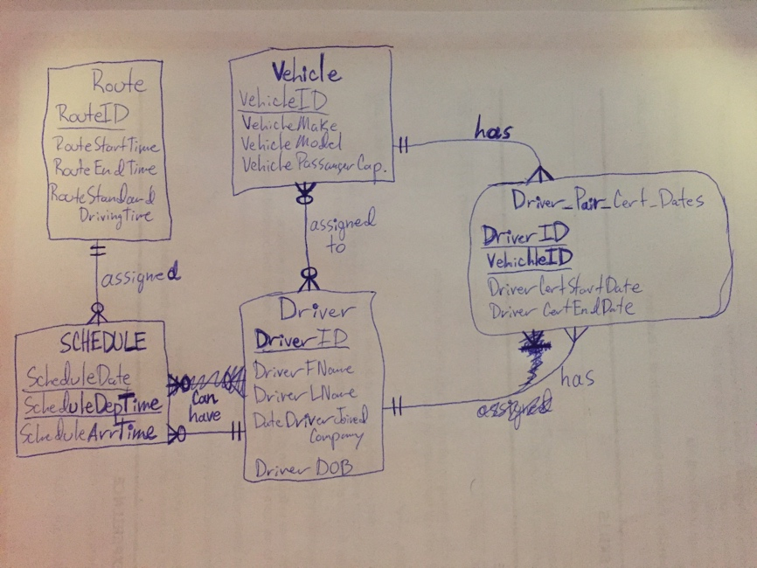

1. Based on the ER diagram you just drew and the case narrative, explore the areas in which there could be opportunities to expand the data model to achieve better tracking of the company’s operations or improved clarity, such as maintaining more detailed route information.
2. The company could keep track of the last time, and the next time, each vehicle needs to be inspected.
3. When each vehicle’s insurance and other related coverages, warranties, etc. will expire and/or need to be renewed.
4. The amount each vehicle cost annually.
5. The specifics of each route could be more detailed, i.e. distance covered, the amount it cost to run a vehicle on the route one full time, and the cost of running the route each year, also, the amount of income from each route.
6. It would also be helpful for the company to know how much each route makes annually/monthly versus how much it cost to maintain the buses and run the route.
7. The schedule table could contain the times the vehicles should arrive at each stop and depart from each stop to help drivers maintain a tighter schedule. This would also help customers time their trips more accurately, which in turn would make using the vehicles more reliable, which would encourage people to use the vehicles.
8. The cost of a ticket on a given route, or given vehicle, should be recorded so that trends/patterns in ticket purchases can be tracked.
9. It would be defining to identify each unique schedule for each route instead of using the schedule date and departure time to identify each one. The numbers could be reused each day or each month but using two keys isn’t the most efficient way to do it.